Session 19: Suburbs and boundaries: the continued push for peripheral expansion
Session Chairs: Prof. Roger Keil / Prof. Alan Mabin

Landscapes of pressure, landscapes of standstill
The (sub)urban edges of Spain's metropolises after the boom del ladrillo

Kathrin Golda-Pongratz
kathrin@pongratz.org

Abstract
Expansionist urban policies and planning practices of the last decade, the creation of a real estate bubble and its final burst with the outbreak of the financial crisis have engendered a dramatic change to the Spanish landscape. What was urbanized at an astonishing pace during the first decade of the 21st century, is left behind unfinished and constitutes urban fringes, vast suburban fields and even natural resorts, especially along the Spanish coast that have turned into scarcely populated ghost cities, made up of orphaned housing structures all over the country.
The urban edges of Madrid are a striking example for such developments and a contemporary monument to the failure of suburban dreams, to the uncontrolled dissipation of resources and a symbol for the negative impacts of uncontrolled speculative urban policies. Yet they are now exposed to even bolder and even less sustainable urban visions: the future inscription of Eurovegas, a conglomerate of mega-casinos of uncertain financing, into Madrid's plains beyond those half-inhabited and unfinished urbanizations.
Barcelona, the Catalan metropolis that claims to follow the logics of a compact city and recently promotes itself as Spain's leading smart city as a resourceful and productive and self-sufficient urban agglomeration, has also been envisioning such this mega-casino project as an economic paradise and as a solution for the ongoing financial crisis. It would even have sacrificed the last remaining agricultural and truly self-sufficient reserves that the city has and is for various reasons far away from fulfilling its protocol of resourcefulness: brownfields, underprivileged neighbourhoods and liminal territories were eliminated and converted into large scale housing promotions that are partly unfinished by the time and partly abandoned.
Highly indebted banks have taken over the ownership from indebted and unemployed former inhabitants and what seemed a suburban promise and urban expression of a welfare state, has suddenly turned into the physical representation of a social drama.
The paper –in form of an essay– unfolds these dramatic urban processes and its immediate and long-term social and territorial consequences, as well as it visualizes the need for civic and urban strategies and the formulation of policies towards a conversion of these contemporary ruins into useful and resourceful post-suburban structures. A photographic essay of those landscapes of pressure accompanies the critical reflection on this phenomenon of large-scale urbanistic failure.

Landscapes of pressure, landscapes of standstill
The (sub)urban edges of Spain's metropolises after the boom del ladrillo

"The territory no longer precedes the map, nor survives it.
Henceforth, it is the map that precedes the territory
- precession of simulacra -
it is the map that engenders the territory
and if we were to revive the fable today,
it would be the territory
whose shreds are slowly rotting across the map.
It is the real, and not the map,
whose vestiges subsist here and there,
in the deserts which are no longer those of the Empire,
but our own.
The desert of the real itself."

Jean Baudrillard

Where the Spanish capital city Madrid touches the landscapes of La Meseta, the dry heights of Castilla it lies in and is surrounded by, the encounters of the urban and the rural are harsh and abrupt: the liminal zones of the metropolitan area are maybe the most radical indicator for the expansionist urban policies and rampant planning practices of the last decade. These urban edges dramatically visualize the impacts of the real estate bubble itself and its final burst with the outbreak of the financial crisis and the consequent complete decadence of the recent massive housing projects over the last quinquennium. Those landscapes of modern ruins testify to a territorial and also to a human disaster.

Under the logics of growth and dispersion
A report of the Ministry of Housing admits that never in the history of Spain more soil was urbanized and housing built than in the decade between 1997 and 2007, subsequent to a national land reform in the late 1990s. Since then, a massive overproduction of multi-family housing properties for the middle classes had been evoking and inciting the massified dream of buying property. „Unfortunately we have, among other things, missed out on the potentials and possibilities in the production of housing. On the peripheries we have built hundreds of new housing units at one go, up to a point when the urbanized and built up territory in Spain has doubled within the last thirty years“ – this is how the phenomenon and its enormous consequences can be summed up.
By the turn of the century, after the tourist boom of the 1980s, we can talk of an excessive total urbanization of the coast. In places like Murcia or Alicante, the positioning of gated communities with gulf courts into ecologic reserves has caused massive problems of water supply. Monofunctional urbanizations in Southern Spain, after falling into a certain decay and having to deal with an aged winter bird society, are surrounded by informal settlements for seasonal workers and by a second ring of rapidly built apartment blocks as speculative objects and second residencies, that, after the burst of the bubble in 2008 are incomplete and can no longer be financed.
The logic of dispersion and of spatial segregation was also the logic of the Spanish economic growth and, as motor for the creation of jobs, basis and consequence of increasing wealth until a few years ago. Migrational pressure and a growing real estate speculation of local and international investors, builders and banks and the related corruption in city councils have converted the country into a sprawled and suburbanized territory. Water supply problems, a massive loss of rural territory on the major cities' peripheries and especially along the coastline and a consequently severe ecological disequilibrium are long-term side effects of these developments.
Vast parts of the population took up credits to buy property, to invest into brick and to achieve the dream of the own or the second home. Real estate promoters promised in colourful announcements a modern, cosy, comfortable and harmonic life within new housing developments, in close contact to nature but at the same time excellently connected to the metropolis. Everybody wanted to keep up with what was (and still is) socially considered a status symbol, a sign of integration and success for immigrants, and a supposed guarantee and the perfect future investment for the entire Spanish society. The urban peripheries are therefore also a place and perfect portrait of social pressure, where the building and real estate sector boomed at an astonishing pace until the financial crisis broke out.

Madrid's new towns of the 21st century - barrios fantasma
Satellite towns of immense extensions, the largest one to provide new homes to 75.000 people, had been planned since the mid 1990s under the denomination of Programas de Actuación Urbanística or Programmes of Urbanistic Action (PAU's). The action consisted of the conversion of rural territory into new satellite towns or a layout thereof, with low densities of an average of 30 inhabitants per hectare, non-functional housing units for low-income families and vast open spaces with very little quality for public activities and gathering.
These new towns, rather hostile and not very urban in their design, somehow comparable to the urban fabrics of mass production at the beginning of the 20th century as well as to the housing estates of the Franco era, spread out into the landscape. Their encounter with the rural soon turned into a physical symbol of the failure of blind urban expansionism. The largest of these developments, Vallecas, foresaw the construction of 28.000 new flats. The extension of Valdecarros, a kind of mega-PAU even further southeast, projects 48.000 new flats, a new business district and several amusement attractions. It is paralyzed now and as such a weird urban monument to the post-boom.
What during a decade had seemed to guarantee welfare and to fulfil both citizens' and politicians' dreams, el boom del ladrillo, the brick boom, has engendered a dramatic change to the Spanish landscape and, at the end of it, left behind unfinished and scarcely populated ghost cities: skeletons of multi-story housing structures, networks of wide paved streets and unconnected street lamps along empty parking lots ending in the fields, lines of benches looking onto empty ponds and half-inhabited apartment blocks with brick-sealed basements where never a store has opened its doors.

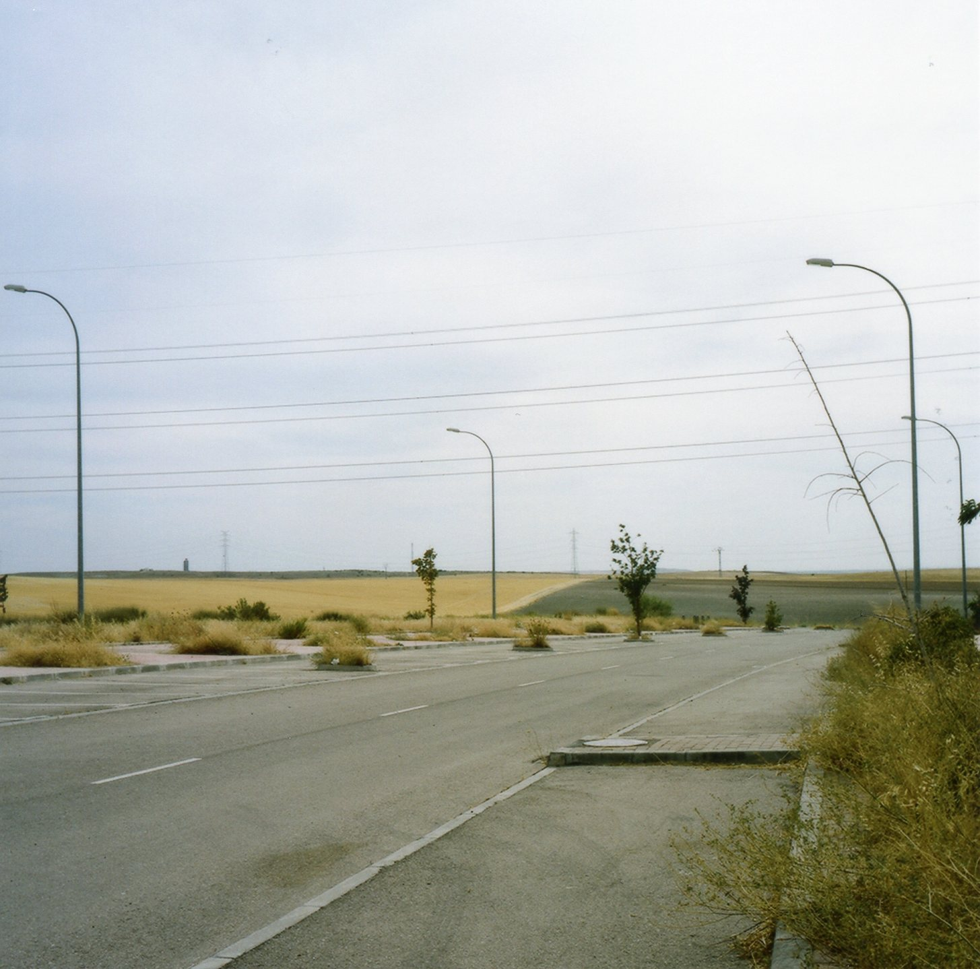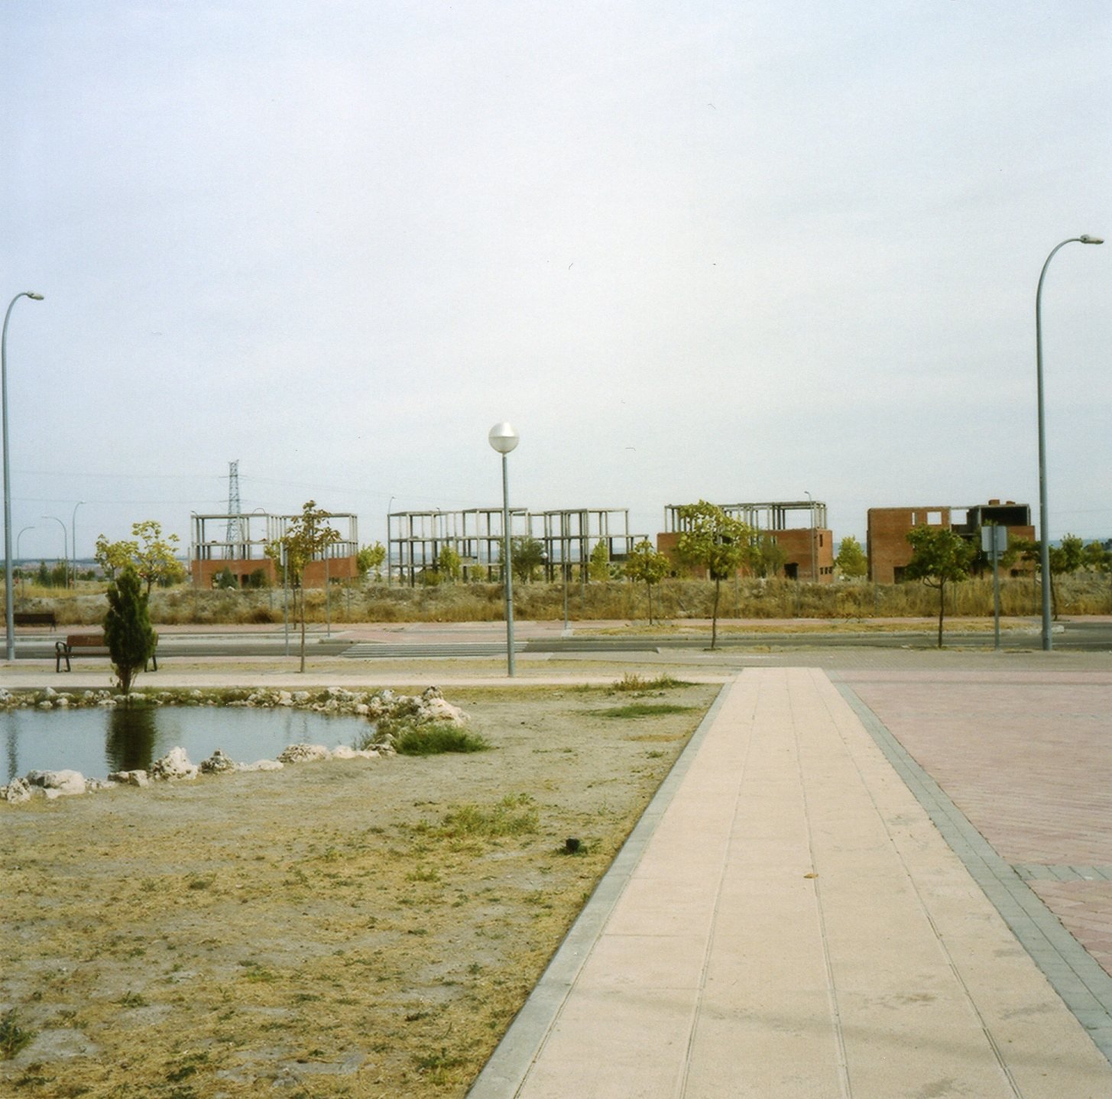
Image 1/ 2: The unfinished new town of Valdecarros/ Madrid, 2012. © Kathrin Golda-Pongratz.

Places of post-consumptionist affection
How can one feel attached to such a place, in case one was attributed one of these new flats by the social housing lottery? Can we even talk of a place? How must it feel to live in such a semi-finished urbanized landscape, next to building skeletons, cranes that stand still since months and slowly decay? What must it be like to have bought one of these semi-detached homes facing the fields in the back and a water feature in the front and where the proud owners end up living without neighbours? What can one hold on, what to attach to? What might, beyond one's living room or balcony overlooking the Valderrama Mountains, be a point or place of affection and a place from where public life can develop within these wastelands of architectural surplus?
Will the mutilated landscape ever merge with the built-up structures that consumed it? Or have the clash of both and the aesthetics of such disharmonious encounter maybe become already a condition of our post-modern existence?
On this periphery of the peripheries, life probably feels like life in a waiting loop, beyond the large parking lots of IKEA, the do-it-yourself stores and the 24/7 supermarkets that suggest unlimited consumption and welfare. It resembles a half-accomplished dream of living away from the hustle of the city, of touching nature and being ultra-modern at the same time. Where the rural has lost its rurality while the urban has not acquired urbanity yet. Where vestiges of dry but colourful plants, of plains and heights touch the ground floors of unfinished concrete structures, of walled empty courtyards or fenced-off wastelands for sale.
In the face of the visibly dramatic consequences of these unmeasured expansionist urban policies, shouldn't the major question be: what comes next? Is there any idea of how to deal with what has left rather harmful traces?

Eurovegas – junket-urbanism for two cities in crisis
While raising such questions, pressure on these territories does not diminish and new urban projects are being spread out on the tables. And lessons seem not to be learned. While still no answers are given with respect to the future of these ghost cities, the land beyond the unfinished urban skeletons is already gambled for more, for what comes after the crisis or might even be the salvation from it - this is at least the political asset of the moment: the installation of Eurovegas, a copy of Las Vegas partly financed by Las Vegas Sands on European grounds, a complex of 800 hectares with casinos, hotels, golf courses, commercial and convention centres.

Barcelona, the Catalan metropolis that claims to follow the logics of a compact city and recently promotes itself as Spain's leading smart city as a resourceful and productive and self-sufficient urban agglomeration, had also been envisioning this mega-casino project as an economic paradise and as a solution for the ongoing financial crisis and put all its resources onto the gambling table.
This corresponds to a recent trend, within which Barcelona is far away from fulfilling its protocol of resourcefulness. In the first decade of the 21st century, the city proclaims an even further extension and promotion of the tourist industry and event-oriented architecture of consumptionism as motors for urban development. At the same time, it offers little urbanistic tools with which to prevent a total commercialization of the city and the loss of its fame as a compact and socially oriented and integrative city.
In the innovation-district 22@ and its larger framework of large-scale urban renewal towards the Eastern edge of the city intents a mixture of functions on paper. The reality though shows that real estate promoters prefer the separation of housing and office use. Therefore, brownfields, underprivileged neighbourhoods and liminal territories were eliminated and converted into such business parks and large monofunctional scale housing promotions that are partly unfinished by the time and partly abandoned. Highly indebted banks have taken over the ownership from indebted and unemployed former inhabitants and what seemed a suburban promise and urban expression of a welfare state, has suddenly turned into the physical representation of a social drama.

For the installation of a mega-casino, which was promoted with the promise of the creation of places of work, the city would even have sacrificed the last remaining agricultural and truly self-sufficient reserves. The Prat de Llobregat delta in the Western metropolitan zone, territory which was selected to compete with Madrid's hinterland for the installation of the casino complex, holds its ecological and regional significance in its name: meadows of the Llobregat river would be its translation. The area of 3.350 hectares, apart from being a natural resort, strategic wetland and protection zone for one of the major aquifers, produces, with 22.000 tons of vegetables per year, a 15 percent of Catalonia's entire production. It is home to micro-industries with 1500 places of work related to agriculture and an important natural resort within the metropolitan zone of Barcelona. In the face of the American magnate's interest to insert the European version of Las Vegas into these grounds, the Catalan government did not hesitate to commission a local architect's office to make a proposal of soil requalification and translate agricultural lands into volumes for gambling and tax-evading leisure activities.

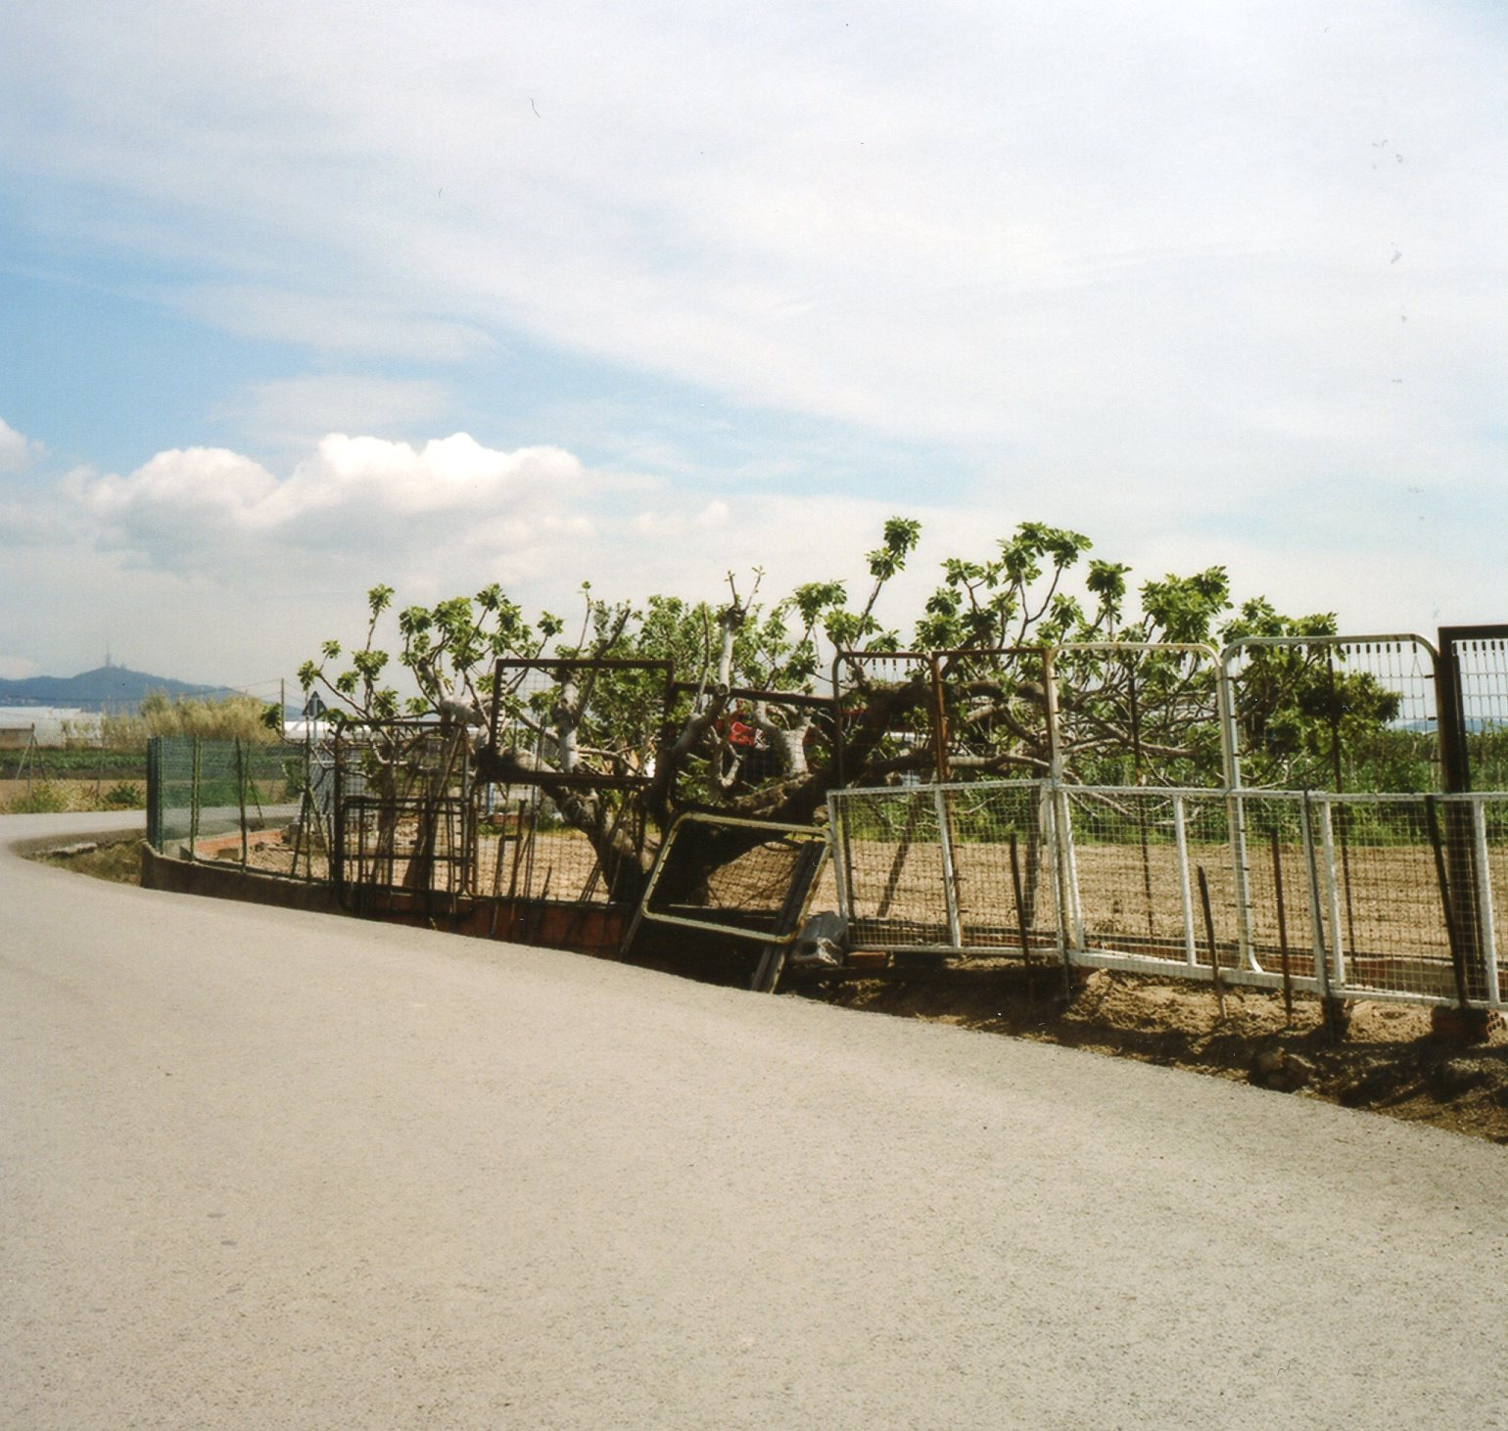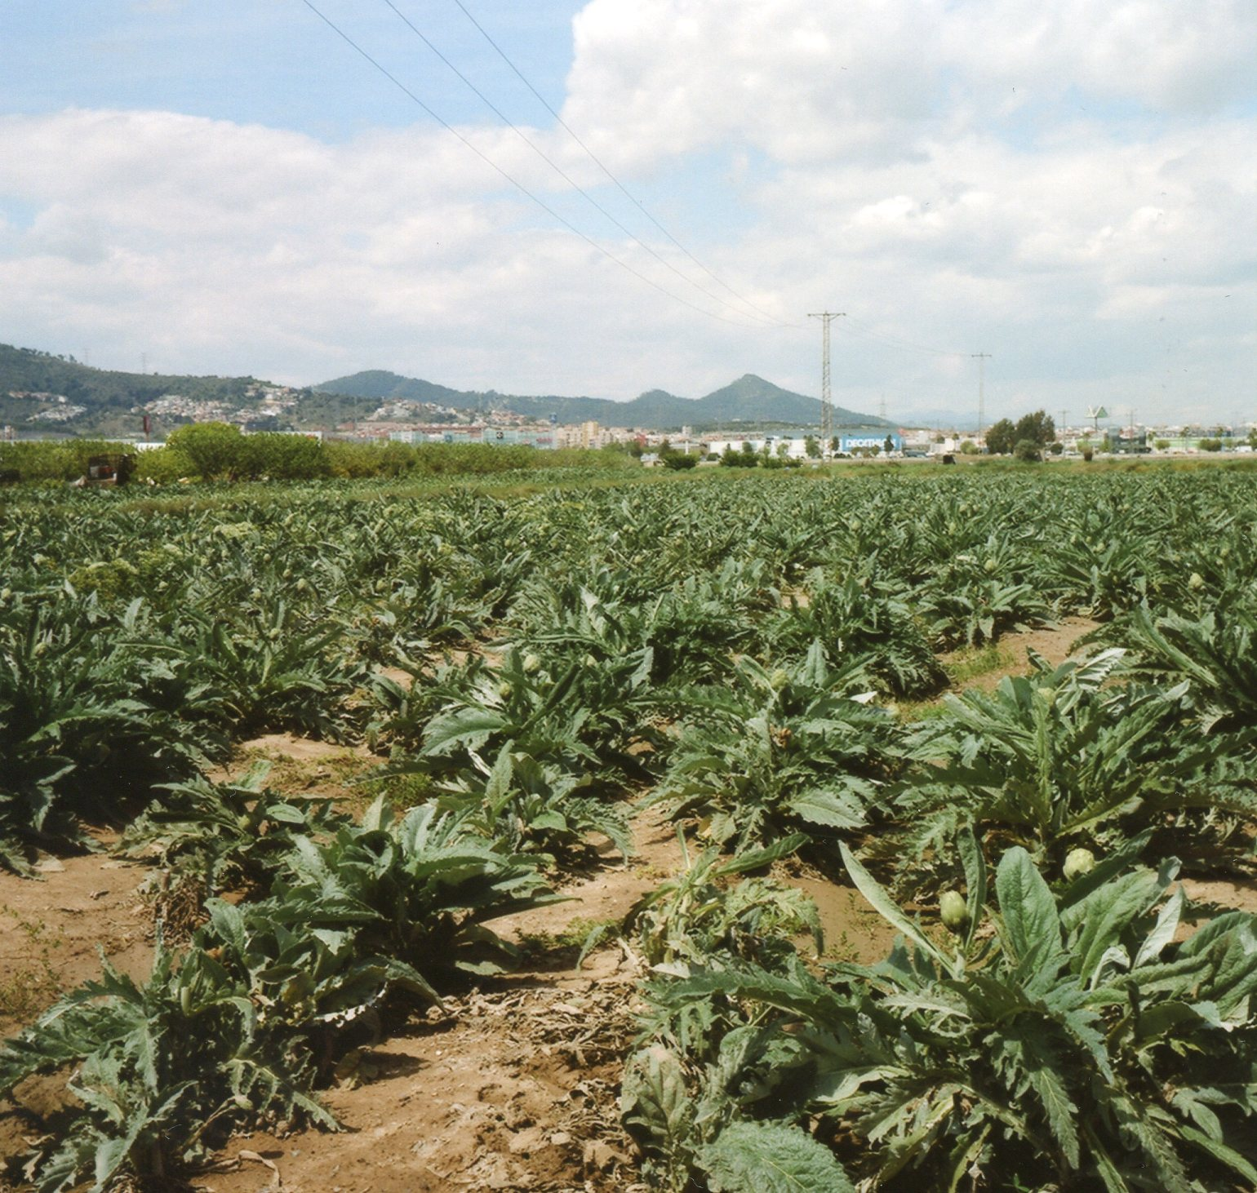
Image 3/ 4: The territories under pressure at El Prat de Llobregat/ Barcelona, 2013. © Kathrin Golda-Pongratz.

Finally, in early September 2012, Madrid won the battle over the project and was preferred by the American investor. Barcelona, instead of taking this defeat as a proof of its more rigid legislation and turning the coin by proclaiming its criteria of sustainability and new opportunities towards a resourceful landscape urbanism, presented another phantasmagorical and semi-legal project the very next day of that decision: its name shall be Barcelona World, located in the province of Tarragona and run and financed by a doubtful businessman who had made all his fortune in the real estate bubble and who has just convinced the son of a Chinese magnate to invest into this counter-response to Eurovegas that includes six theme parks and several hotel complexes.

Valdecarros or Alcorcón - the gamble has begun (and the die is cast)
According to the recently stepped down president of the community of Madrid, who showed herself enthusiastic about the selection of Madrid, such a mega-casino, which requires crucial adaptations of Spanish land and labour laws, will be "a very important inversion in these times of crisis" and will finally "create 200.000 jobs in the service industries, without counting all the jobs of its construction." And according to her successor, it will be "the next two years' most important investment in Spain, if not in the entire world".
In front of such promises, the central government has promised to facilitate whatever needed or requested by the investor, who is selling simulacra and dreams while buying the evasion of legality. A tax reduction from a forty to a ten percent on gambling incomes is offered to the investor. Unlimited heights for the skyscrapers of the complex will be allowed, a speed train stop opened and possibly even a new airport be built for it. After a long and non-transparent dispute between Valdecarros and Alcorcón, it seems now to be decided that the second shall be a gambling paradise in the near future. Unsure, for sure, one feels about what is more striking - the blind belief into this simulation of welfare by repeating the failed logics of a recent past or the phantasmagorical project itself.

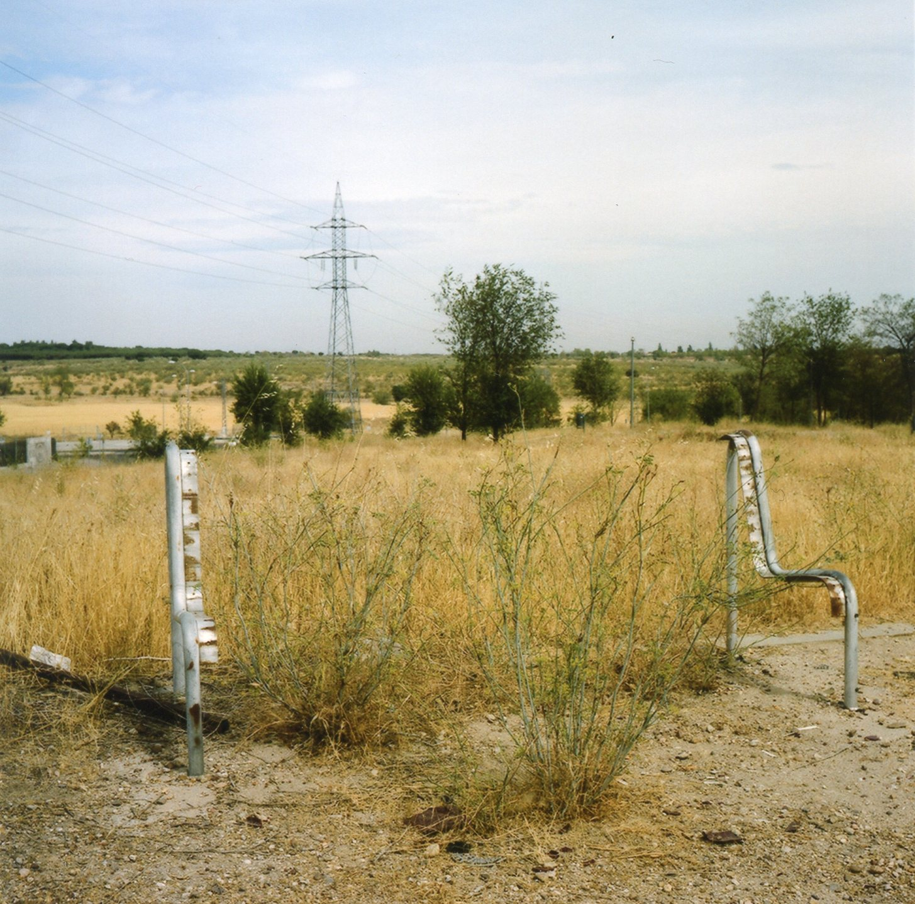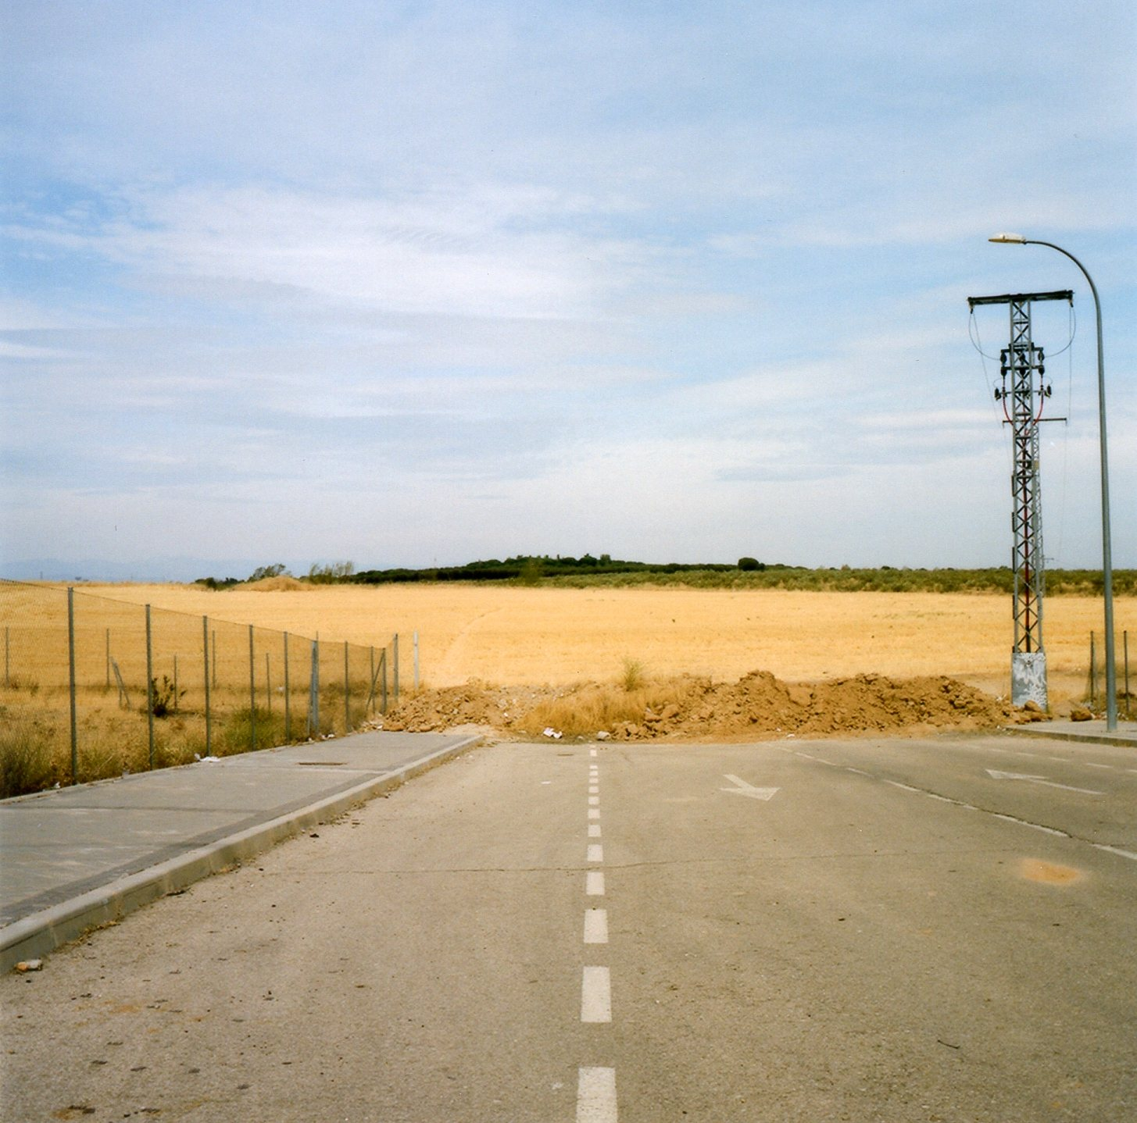
Image 5/ 6: The fields designated to become Eurovegas in Alcorcón/ Madrid, 2012. © Kathrin Golda-Pongratz.

Looking over those vast fields, with one's back to the precarious structures of a decade of rampant capitalism, does one really desire and imagine mega-casinos, golf courses and speculative architectures that will exploit both those who will work there as well as the territory itself? Aren't we, in fact, standing in front of or even in the middle of the desert of the real itself?

References
Aguirre, Esperanza (2012), quoted in: "Aguirre: Eurovegas estará en marcha en 2-3 años desde que se coloque la primera piedra". In: El Mundo. Madrid, 9.9.2012.

Baudrillard, Jean (1994): Simulacra and Simulations. University of Michigan Press, Ann Arbor.

García Gallo, Bruno (2013): "Duelo a 300.000 la apuesta". In: El País. Madrid, 11.6.2013.

Golda-Pongratz, Kathrin (2012): "Formen der Mixicidad und Segregation in Spanien". In: Soziale Mischung in der Stadt. Harlander, Tilman/ Kuhn, Gerd (Eds.), Stuttgart, pp. 220-225.

González, Ignacio (2013), quoted in: "Eurovegas comenzará a construirse este año en los terrenos de Alcorcón". In: La Vanguardia. Barcelona, 9.2.2013.

Herreros, Juan (2009): "De la periferia al centro. La ciudad en tiempos de crisis". In: Alfaya, Luciano/ Muñiz, Patricia (Ed.): La ciudad, de nuevo global. Santiago de Compostela.

Ministerio de Vivienda (Ed.) (2010): Informe sobre la situación del sector de la vivienda en España. Madrid.

Palomero Ferrer, Jorge (2009): Public Space and Urban Vitality in the PAU of Madrid. Working paper for the conference City Futures, Madrid.

Plataforma Aturem Eurovegas (2012): Salvem el Delta del Llobregat. Barcelona.

Baudrillard, Jean: Simulacra and Simulations. University of Michigan Press, Ann Arbor 1994, p.1.
Ministerio de Vivienda (Ed.): Informe sobre la situación del sector de la vivienda en España. Madrid 2010, p.8.
Herreros, Juan: De la periferia al centro. La ciudad en tiempos de crisis. In: Alfaya, Luciano/ Muñiz, Patricia (Ed.): La ciudad, de nuevo global. Santiago de Compostela 2009, p. 253.
Golda-Pongratz, Kathrin: "Formen der Mixicidad und Segregation in Spanien". In: Soziale Mischung in der Stadt. Harlander, Tilman/ Kuhn, Gerd (Eds.), Stuttgart 2012, p. 221 f.
Palomero Ferrer, Jorge: Public Space and Urban Vitality in the PAU of Madrid. Working paper for the conference City Futures, Madrid 2009, p. 4.
Junket describes a person or firm, some of them figuring in the Nasdaq index, whose work consists in capturing rich casino gamblers, paying for their expenses, financing their bets and making sure the will pay their debths. Explained in: García Gallo, Bruno (2013): "Duelo a 300.000 la apuesta". In: El País. Madrid, 11.6.2013.
Golda-Pongratz, Kathrin: "Formen der Mixicidad und Segregation in Spanien". In: Soziale Mischung in der Stadt. Harlander, Tilman/ Kuhn, Gerd (Eds.), Stuttgart 2012, p. 223.
Plataforma Aturem Eurovegas (2012): Salvem el Delta del Llobregat. Barcelona, p. 2.
Aguirre, Esperanza, quoted in: "Aguirre: Eurovegas estará en marcha en 2-3 años desde que se coloque la primera piedra". In: El Mundo. Madrid, 9.9.2012.
González, Ignacio, quoted in: "Eurovegas comenzará a construirse este año en los terrenos de Alcorcón". In: La Vanguardia. Barcelona, 9.2.2013.

